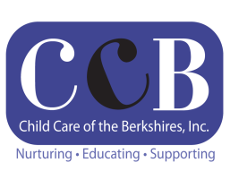
CHILD CARE OF THE BERKSHIRES, INC.
HOLIDAY CLOSURES FY 2021
JULY 1, 2020 – JUNE 30, 2021

JULY Friday, July 3rd - Independence Day Holiday (Observed)
AUGUST No closures

SEPTEMBER Monday, September 7th - Labor Day Holiday
Monday, September 14th - All Child Care Programs & FCC

OCTOBER Thursday, October 15^{th -} Training Day-All Child Care Programs & FCC
Monday, October 12th - Columbus Day Holiday

NOVEMBER Wednesday, November 11th Training Day- All Child Care Programs & FCC
Thursday, November 26th & Friday, November 27th
Thanksgiving Holidays

DECEMBER Thursday, December 24th & Friday, December 25th
Christmas Eve (Observed) & Christmas Day

JANUARY Friday, January 1st - New Year’s Day
Monday, January 18th - Martin Luther King Jr. Holiday

FEBRUARY Monday, February 15th - Presidents’ Day Holiday

MARCH Monday, March 15th Training Day- All Child Care Programs & Family Child Care

APRIL Monday, April 19th - Patriots’ Day Holiday

MAY Monday, May 31st - Memorial Day Holiday

JUNE Monday, June 1st Family Support, Child Care & FCC Training

12 Holidays and 5 Professional

